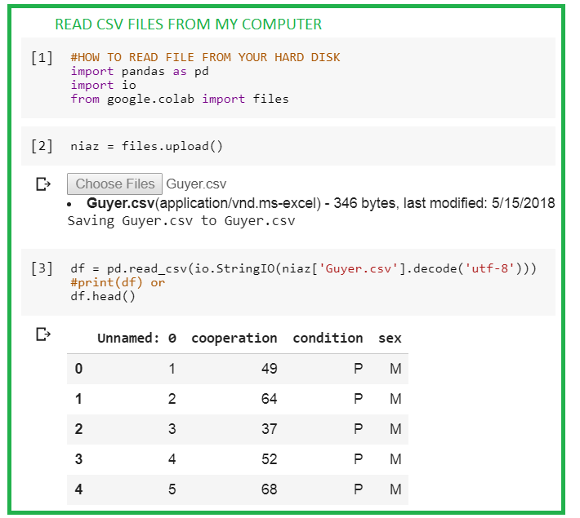

HOW TO DOWNLOAD AND READ CSV FILE IN COOLAB GOOGLE

<https://vincentarelbundock.github.io/Rdatasets/datasets.html>

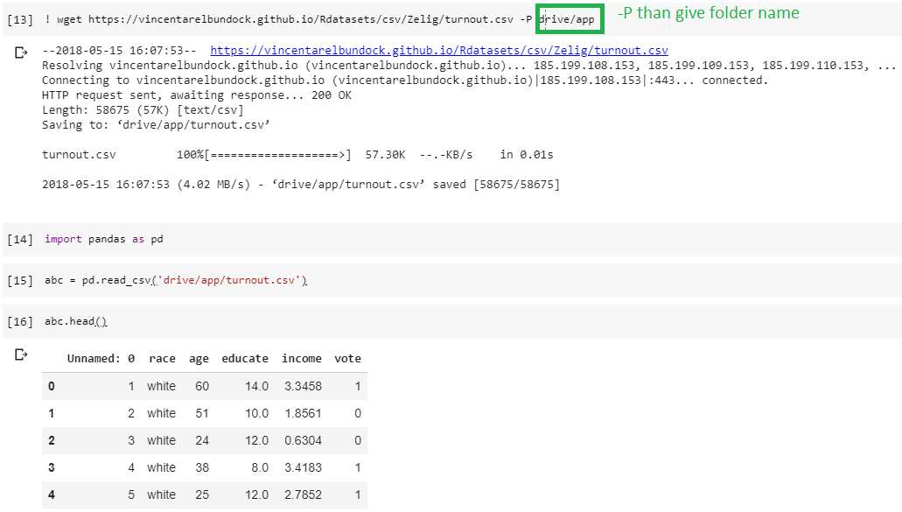

DOWNLOAD AND READ

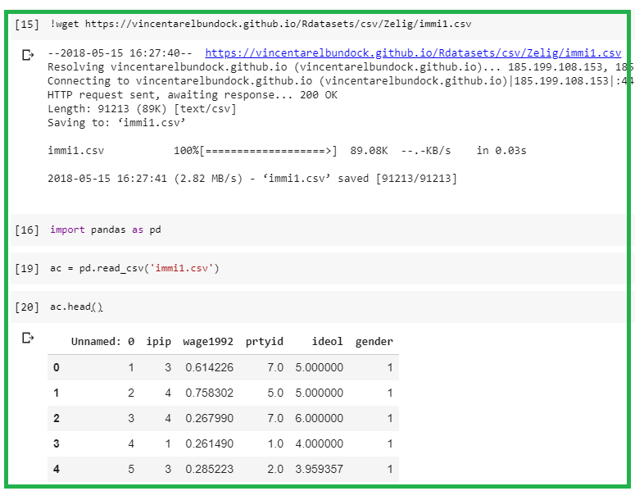

SIMPLE TRAINING ON COOLAB

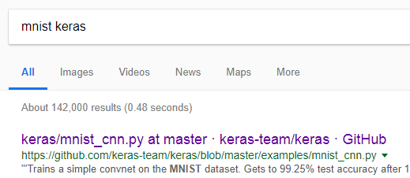

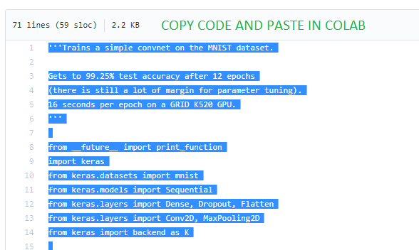

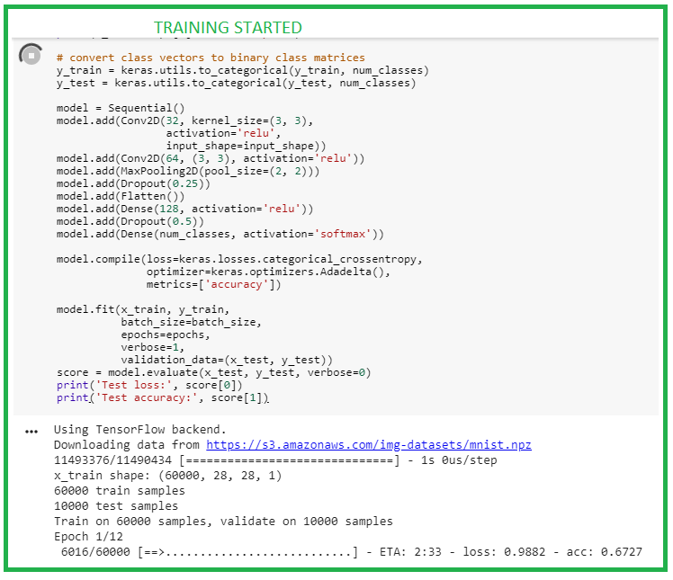

DOWNLOAD FROM GITHUB

<https://www.youtube.com/watch?v=Hs6HI2YWchM>

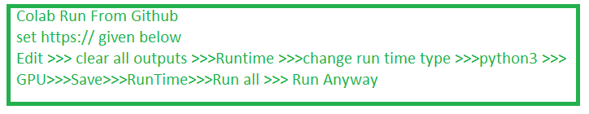

<https://colab.research.google.com/github/Hvass-Labs/TensorFlow-Tutorials/blob/master/01_Simple_Linear_Model.ipynb#scrollTo=V8LJcdaxiolX>

